Maria DB

Name : 黃斌生

ID : 41331J04

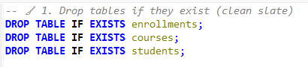

The first step is to write this code, this code is a reset mechanism in SQL. The purpose is to minimize error, what it does is it deletes the table if the table already exists. This code prevents “Table ‘student’ already exists” from happening which will make your code not work.

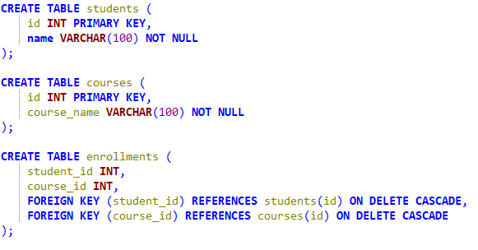

The second step is to write this code which makes the table for the database. There are three parts of this code. The first is “create table student” which stores the student information, it has two columns ‘id’ and ‘name’ this is to make sure that every student has a unique id. “NOT NULL” is a code that means that the ‘name’ and ‘course_name’ cannot be empty and every ‘name’ and ‘course_name’ must have a value. The second part is a table about the courses that the students have. It has the same code as the first part. The third part is different from the other two because it has “foreign key” and “references”. “Foregin key” this code is the one that makes the links between two tables “students” and “courses”. “References” this code is just another way of saying ‘student_id’ and ‘courses_id’. “On delete cascade” this code works if one of the students or courses is deleted, the related enrollments are automatically deleted.

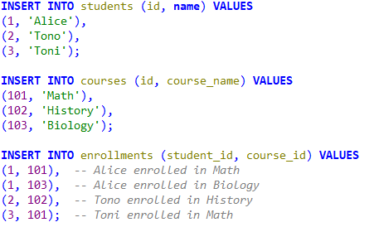

The third step is to input the data to the database. We do this by using the code “insert into” we can use this code on all three parts: students,courses, and enrollments. The numbers are id’s that are used specifically for one courses or students.

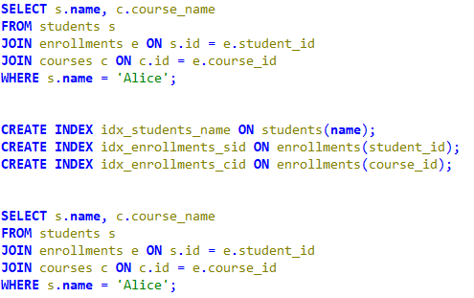

This is the last step of the code, the first part is the one that makes the tables join together. The first part is index, without index the SQL will search the entire table to find matches and would be slower for larger databases. The second part, code “where” is the one that filters the rows and returns Alice's name and the name of the courses that she’s in.